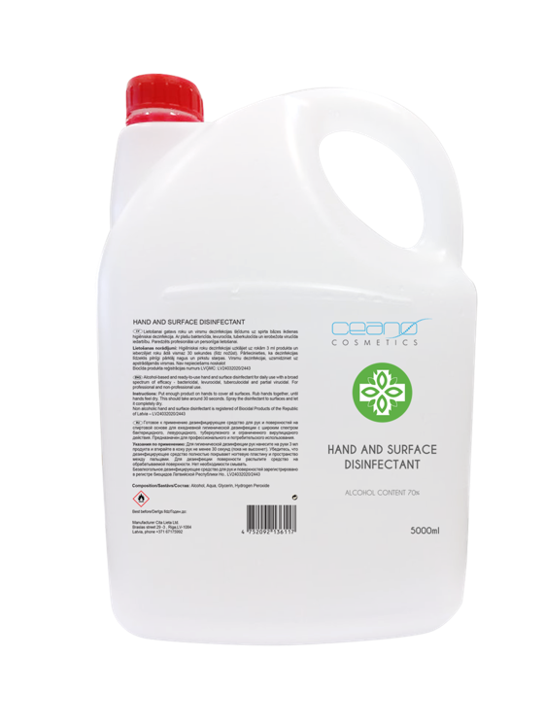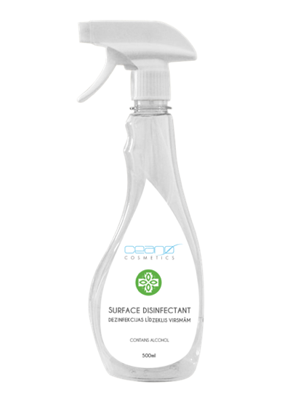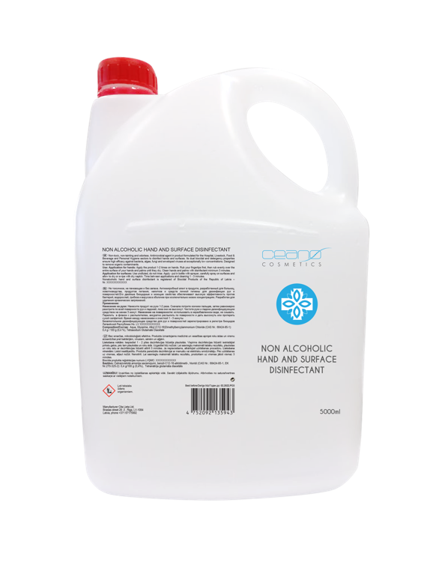

DISINFECTANT
For Hands and Surfaces Disinfectant for Surfaces Disinfectant for Hands and Surfaces
BIOCIDE Disinfectant for Hands and Surfaces
BIOCIDE Disinfectant for Hands and Surfaces

Alcohol % 70% 70% -
-

Consistency Liquid Liquid Liquid

Volume Packaging 500 ml bottle, spray
5 L bottle, screw cap 5 L bottle, screw cap
1000 L IBC

LIQUID SOAPS For Hands and Body Liquid Soaps
Liquid Soaps
Liquid Soaps

Consistency Liquid Liquid
Liquid

Volume Packaging 500 ml bottle, flip top
1 L bottle, flip top
5 L bottle, screw cap

MOQ/pcs 500 500

Marta Blaua Sales Manager CITA LIETA Ltd.
Private Label Company
Mob.tel.: +371 29693610 Mail to: marta@soap.lv Braslas str. 29, Riga
LV-1084, Latvia
Tel.: +371 67175992 Fax: +371 67175992
www.ceanocosmetics.com
www.citalieta.com

